**Nexus Database Migration from OrientDB to PostgresQL**

Why upgrade Required?

<https://help.sonatype.com/en/orientdb-downloads.html>

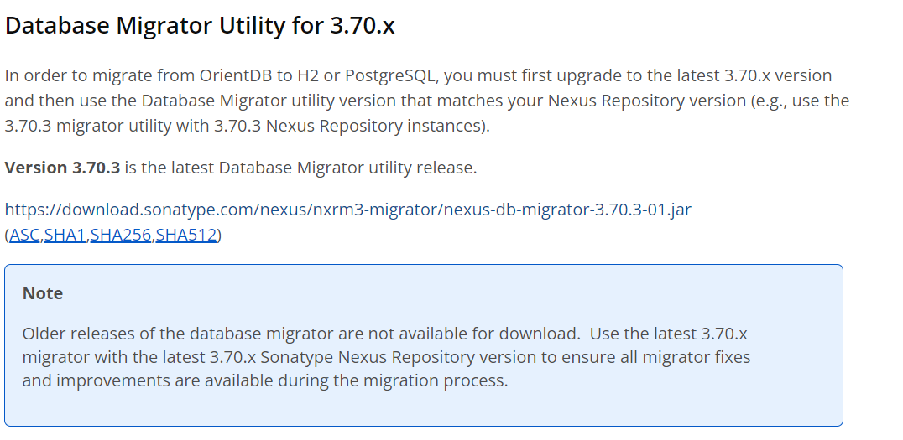

**Reference Taken** : <https://help.sonatype.com/en/migrating-to-a-new-database.html>

**Step # 01**: upgrade the existing (3.68.1-02) nexus repository to 3.70.3-01

<https://help.sonatype.com/en/download-archives---repository-manager-3.html#sonatype-nexus-repository-3-70-3-01>

**upgrade guide reference:**

<https://help.sonatype.com/en/upgrading-a-standalone-instance.html>

<https://support.sonatype.com/hc/en-us/articles/115000350007-Upgrading-Nexus-Repository-Manager-3>

<https://help.qlik.com/talend/en-us/migration-upgrade-guide/7.3/upgrading-from-nexus-3.x-to-latest-nexus-3.x-version-available>

**Step # 02**: download the migrator utility similar to the upgraded version i.e. 3.70.3-01

<https://download.sonatype.com/nexus/nxrm3-migrator/nexus-db-migrator-3.70.3-01.jar>

**Step # 03:** In a PostgreSQL server, create a database called **nexus**. (When creating your database, ensure it is set to use UTF8 as its character set in order to be compatible with Nexus Repository's character set)

**Step # 04:** We recommend setting the PostgreSQL autovacuum configuration to be on.(<https://www.postgresql.org/docs/current/runtime-config-autovacuum.html>)

**Step # 05:** In the sonatype-work/nexus3/etc/fabric/ directory (i.e., $data-dir/etc/fabric),

create nexus-store.properties; below is a sample that you will need to update with the appropriate configuration.

***username=<postgres_user>***

***password=<postgres_password>***

***jdbcUrl=jdbc\:postgresql\://<database-host>\:<database-port>/nexus***

**Step # 06:** Servers under heavy load may also need to configure the connection pool size for the database. Nexus Repository uses a default pool of 100, but you may increase this by appending a line like the following example to nexus-store.properties:

***advanced=maximumPoolSize\=200***

**Step # 07:** Add the following to $data-dir/etc/nexus.properties

***nexus.datastore.enabled=true***

**Step #08:** step 8: Perform a full backup using the backup task(<https://help.sonatype.com/en/configure-and-run-the-backup-task.html>)

**Step # 09:** Copy the backup to a clean working location on a different filesystem so that any extraction doesn’t impact the existing production system

**Step # 10:** step 10: Shut down Nexus Repository

systemctl stop nexus.

**Step #11:** Update and run the following command from the clean working location containing your database backup. Use the appropriate values for host, port, username, password, and migrator utility jar file name. You can also include any of the [optional parameters from the section below](https://help.sonatype.com/en/migrating-to-a-new-database.html#optional-parameters-162010) when running this command.

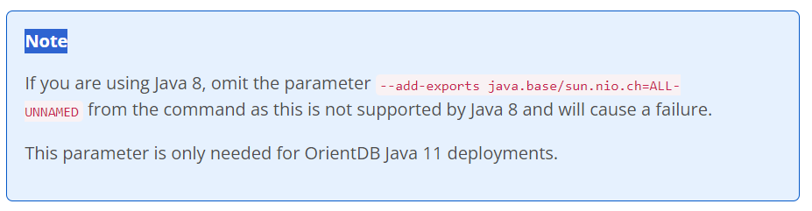

**java -Xmx16G -Xms16G -XX:+UseG1GC -XX:MaxDirectMemorySize=28672M --add-exports java.base/sun.nio.ch=ALL-UNNAMED -jar nexus-db-migrator-*.jar --migration_type=postgres --db_url="jdbc:postgresql://<database URL>:<port>/nexus?user=<postgres_user>&password=<postgres_password>"**

**Step # 11:** Run the following command on the Nexus Repository database after migrating but before starting Nexus Repository. This will reclaim storage occupied by obsoleted tuples left from the migration.

**VACUUM(FULL, ANALYZE, VERBOSE);**

**Step # 12:** start the nexus repository

systemctl status nexus

**Step #13:** in case of failure revert back to Orient DB

<https://help.sonatype.com/en/legacy-database-migration.html#reverting-back-to-orientdb-223434>

**Reverting Back to OrientDB**

The migration process is one-way: the migrator utility can extract configuration and component metadata from OrientDB and move it to H2 or PostgreSQL, but not vice versa. However, **migration is non-destructive**, and the OrientDB still exists as a restoration point until you delete it.

**Note**

Once you start a Nexus Repository instance, database and blob storage contents will diverge. After this, reverting to Orient will require restoring the blobstore(s) from backup.

If it is necessary to revert back to OrientDB, take the following steps:

1. Shut down Nexus Repository.
2. Return to OrientDB mode byediting the $data-dir/etc/nexus.properties file and remove the following line:

nexus.datastore.enabled=true

1. Restart Nexus Repository.

This will bring Nexus Repository configuration and component metadata back to the point in time when the migration first took place. We recommend running the blob store reconciliation task after reverting to reconcile any changes to the blob store with the database.

This doesn't undo any additions or deletions to binaries that you may have made since the migration